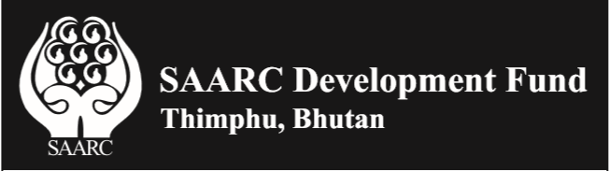

Vacancy Announcement
for
Director, Economic & Infrastructure Windows
Applications for the above position are invited from the Nationals of SAARC Member States (Afghanistan, Bangladesh, Bhutan, India, Maldives, Nepal, Pakistan and Sri Lanka) for appointment at the SAARC Development Fund, Thimphu, Bhutan.

The Terms of Reference (TORs) and prescribed Application Form for the above-mentioned position is available on SDF website www.sdfsec.org. Application Form, CV, copies of educational certificates and experience letters should be sent by email to ceo@sdfsec.org and admin@sdfsec.org latest by October 14, 2019.

Dr. Sunil Motiwal
Chief Executive Officer

